Market Monitor - Burkina Faso - 2026-04

Highlights
Staple food prices in Burkina Faso continued their strong deflationary trend in April 2026. The cost of the food basket and most individual cereals decreased significantly compared to both the previous month and the previous year.
The national average cost of the food basket decreased by 1.3% month-over-month and 28.5% year-over-year, now standing at 3,600.36.
- Maize (white) prices continued to fall, dropping 2.3% MoM and showing the largest annual decrease of 35.7% YoY.
- Millet experienced the sharpest monthly price decline, falling by 3.6% MoM.
- Beans (niebe) were the only monitored commodity to see a monthly price increase, rising by 1.5% MoM, though they remain down 31.0% YoY.
Key Drivers:
- Significant year-over-year deflation: Prices for all monitored staples have fallen substantially compared to April 2025, with the food basket cost down 28.5% and individual commodities like maize down 35.7%.
- Continued monthly price drops for cereals: Most cereals became cheaper in April, led by millet (↓3.6%) and maize (↓2.3%), contributing to the overall basket's 1.3% monthly decline.
- Divergent trend for beans: In contrast to cereals, the price of beans (niebe) increased by 1.5% month-over-month, marking it as the only commodity in the basket to see a monthly price rise.
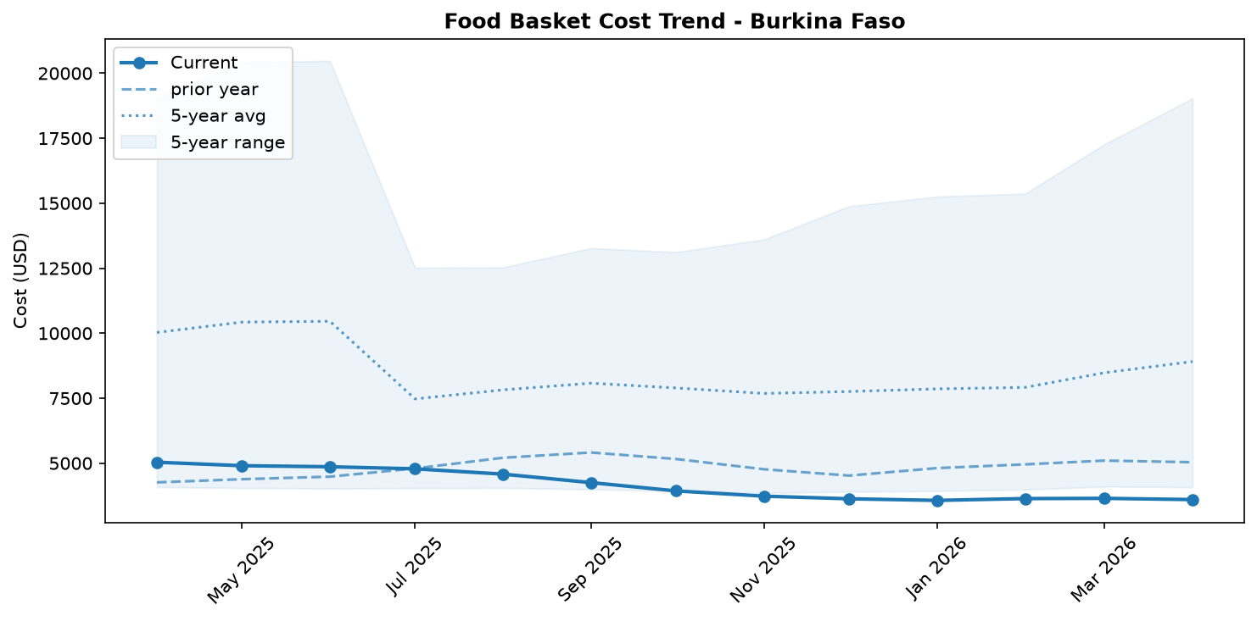
Food basket cost trend

Market Overview
Staple food markets in Burkina Faso continued to experience a strong deflationary trend in April 2026, enhancing food access for market-reliant households. The cost of the standard food basket registered a significant year-over-year decrease of 28.5%, coupled with a more moderate but consistent month-over-month drop of 1.3%. This downward price trajectory is primarily driven by broad-based price reductions across all monitored cereals, particularly maize and millet. The current market conditions reflect a notable improvement from previous years, which were characterized by price pressure from a prolonged security crisis and climate shocks. While a relative improvement in security during 2025 may have contributed to better market functioning, significant humanitarian challenges persist. As of April 2026, an estimated 2 million people remain internally displaced, and 1.7 million face food insecurity. This highlights a critical paradox where falling national prices have not fully translated into food security for all, particularly for populations whose purchasing power remains severely constrained. The outlook suggests that the general deflationary trend for staple foods is likely to continue or stabilize in the near term, though localized access issues will remain a primary concern for vulnerable groups.

Commodity Analysis
An analysis of individual commodities reveals that the overall deflationary trend is largely dictated by major cereals, though with some variation. Maize (white) prices are a key driver of the basket's decline, showing a substantial 35.7% drop year-over-year and a continued 2.3% decrease from the previous month. Millet experienced the most significant month-over-month price fall at -3.6%, and its price is also down 27.1% compared to April 2025, indicating strong downward pressure on its market. Sorghum (white) prices were perfectly stable month-over-month but remain aligned with the annual trend, posting a large 28.4% year-over-year decrease. In contrast, local rice demonstrated relative stability, with only a minor 0.6% monthly decrease; its 15.4% year-over-year reduction is the smallest among the monitored staples, though still significant. The notable exception to the monthly trend is beans (niebe), which saw a slight price increase of 1.5%. This suggests a recent tightening in the bean market, potentially due to specific supply-side factors. However, this minor uptick follows a period of major price correction, as bean prices remain 31.0% lower than the previous year. Overall, the strong downward momentum of cereals continues to outweigh the slight monthly increase observed for beans.
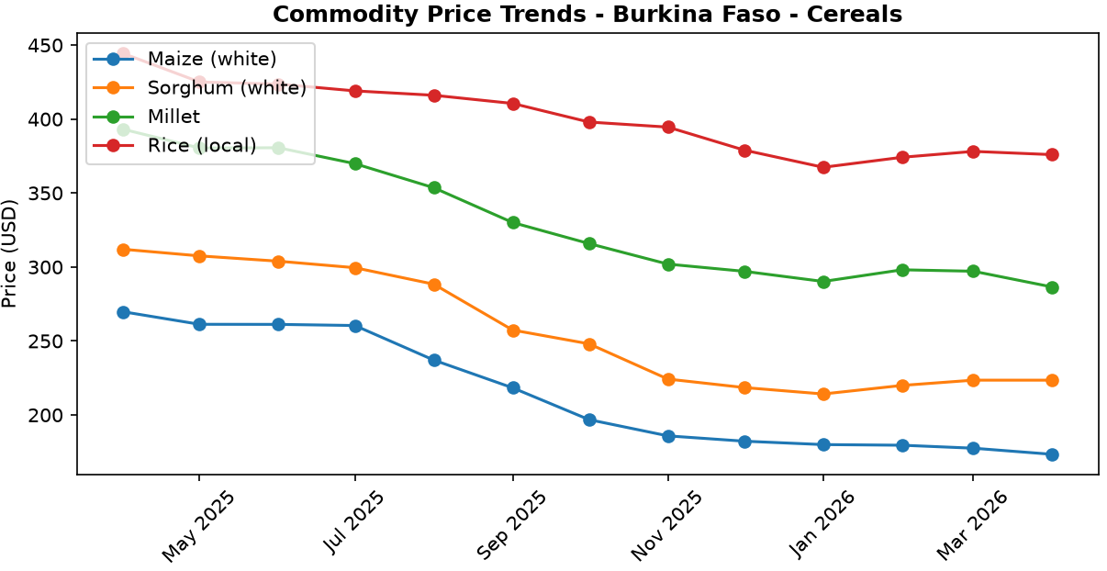
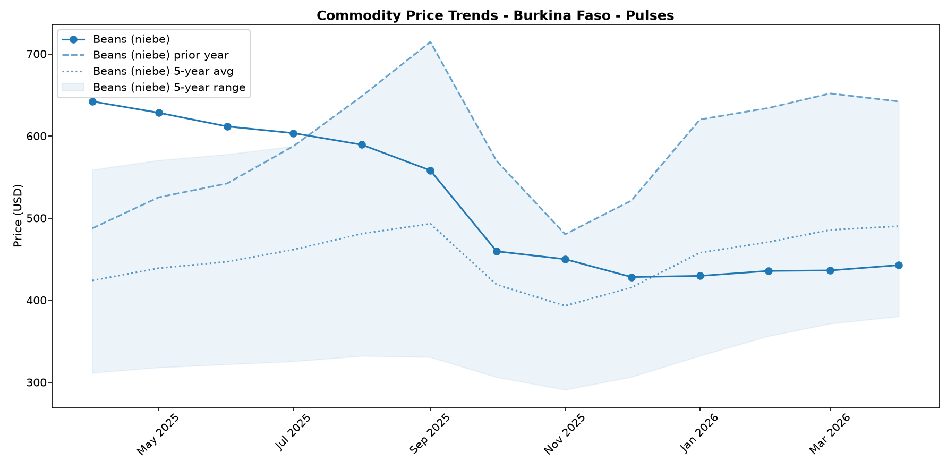

Regional Highlights
At the national level, market dynamics are favorable, with the cost of the food basket falling by 28.5% over the past year. However, this aggregate trend masks severe localized challenges where price is not the primary barrier to food access. In Karo-Peli Province, for example, households continue to face Crisis-level food insecurity (IPC Phase 3) despite the availability of cheaper staples on national markets. Reports from April 2026 indicate that vulnerable households have already depleted their own-produced food stocks and possess weak purchasing power due to limited income-earning opportunities. This severely constrains their ability to acquire food, regardless of price reductions. While food assistance provided in March 2026 alleviated immediate needs for a large portion of the population, the underlying economic vulnerability persists. The situation in Karo-Peli underscores a critical disconnect: national price deflation does not guarantee food security for populations whose access is primarily limited by displacement, insecurity, and a lack of income.
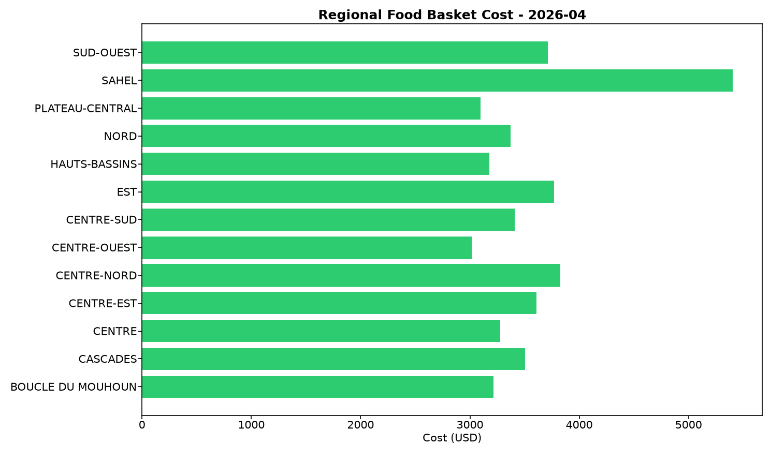

References
- [rw_4208918] ReliefWeb (2026-04-22) UNICEF Executive Director Catherine Russell’s remarks at the Humanitarian Dialogue – Humanitarian Priorities for Children in 2026
https://reliefweb.int/node/4208918
- [rw_4208090] ReliefWeb (2026-04-17) Rapport final indice de fonctionnalite des marches 2025
https://reliefweb.int/node/4208090
- [rw_4207091] ReliefWeb (2026-04-13) WFP Burkina Faso Country Brief, March 2026
https://reliefweb.int/node/4207091
- [rw_4207009] ReliefWeb (2026-04-13) Burkina Faso Key Message Update: Crisis (IPC Phase 3) persists in the north and east amid the lean season, March - September 2026
https://reliefweb.int/node/4207009
- [rw_4206645] ReliefWeb (2026-04-09) Integrating nutrient supplements and WASH into agriculture programs improves child micronutrient status in Burkina Faso
https://reliefweb.int/node/4206645
- [rw_4205328] ReliefWeb (2026-03-31) West and Central Africa: Latest Events at a glance (24 - 30 March 2026)
https://reliefweb.int/node/4205328
- [rw_4205099] ReliefWeb (2026-03-30) Bi-monthly Pastoral Surveillance bulletin in the Sahel N°35 / October-November 2025
https://reliefweb.int/node/4205099
- [rw_4205066] ReliefWeb (2026-03-30) Bi-monthly Pastoral Surveillance bulletin in the Sahel N°36 / December 2025 - January 2026
https://reliefweb.int/node/4205066
- [rw_4204694] ReliefWeb (2026-03-27) Situation in Central Sahel, Liptako Gourma and Coastal Countries - DTM Monthly Dashboard #65 (February 2026)
https://reliefweb.int/node/4204694
- [rw_4204486] ReliefWeb (2026-03-26) UNICEF West and Central Africa Region Humanitarian Situation Report No. 2 (End of Year), 31 December 2025
https://reliefweb.int/node/4204486
- [seerist_1028284] Seerist (2026-04-24) Government purchase of stake in mine underlines HIGH regulatory, contract risks for mining operators
- [seerist_1028238] Seerist (2026-04-21) Big Picture series: Hard currency decisions – Sahel juntas unlikely to abandon CFA franc
- [seerist_1028144] Seerist (2026-04-14) Big Picture series: Strait of Hormuz disruption to drive acute fiscal, supply chain challenges in Africa
- [seerist_1027861] Seerist (2026-03-20) Big Picture series: Beyond health – the implications of the America First Global Health Strategy

